High Level Design (HLD)

Entertainer Data Analysis

Last date of revision: 24/05/2024

AUTHOR: Divakar K G

[AUTHOR NAME] 1



**Document Version Control**

**Date Issued**

**Version**

**Description**

**Author**

**24th May 2024**

1.0

First Version of Complete HLD

Divakar K G



[AUTHOR

**Contents**

|  |  |  |  |
| --- | --- | --- | --- |
| Document Version Control......................................................................................................... | | | 2 |
| Abstract ...................................................................................................................................... | | | 3 |
| 1 | Introduction ............................................................................................................................. | | 4 |
|  | 1.1 | Why this High-Level Design Document? ......................................................................... | 4 |
|  | 1.2 | Scope ............................................................................................................................... | 4 |
| 2 | General Description ................................................................................................................ | | 5 |
|  | 2.1 | Product Perspective & Problem Statement ..................................................................... | 5 |
|  | 2.2 | Tools used ........................................................................................................................ | 5 |
| 3 | Design Details ......................................................................................................................... | | 6 |
|  | 3.1 | Functional Architecture .................................................................................................... | 6 |
|  | 3.2 | Optimization ..................................................................................................................... | 7 |
| 4 | KPIs ......................................................................................................................................... | | 7 |
|  | 4.1 | KPIs (Key Performance Indicators) ................................................................................. | 7 |
| 5 | Deployment ............................................................................................................................. | | 8 |

**Abstract**

The entertainment world is where people entertain others through music, acting, comedy, dance, and more. Their main job is to make people happy and engaged, often reflecting what's happening in society. This industry includes many jobs, like singers, actors, comedians, and TV personalities. These entertainers are often famous and can influence how people think and feel.

Movies and TV shows are a big part of our lives, shaping how we talk, dress, and act. We all have favorite movies or actors we love. Good movies and stars are always celebrated, showing how much they matter to us. But getting and staying successful in this industry is tough. It takes a lot of hard work, whether you're an actor, a technician, or someone who makes movies happen.

This analysis looks at the work and awards of entertainers. It also compares different movies over the years. By looking at all this, we can learn about how movies have changed and why some are more successful than others.

[AUTHOR NAME]



**1 Introduction**

**1.1 Why this High-Level Design Document?**

The purpose of this High-Level Design (HLD) Document is to add the necessary detail to the current project description to represent a suitable model for coding. This document is also intended to help detect contradictions prior to coding, and can be used as a reference manual for how the modules interact at a high level.

The HLD will:

* Present all of the design aspects and define them in detail
* Describe the user interface being implemented
* Describe the hardware and software interfaces
* Describe the performance requirements
* Include design features and the architecture of the project
* List and describe the non-functional attributes like:

Application

Compatibility

Maintainability

Portability

Reusability

Reliability

Resource Utilization

Security

Serviceability

**1.2 Scope**

The HLD documentation presents the structure of the system, such as the database architecture, application architecture (layers), application flow (Navigation), and technology architecture. The HLD uses non-technical to mildly-technical terms which should be understandable to the administrators of the system.

**2 General Description**

**2.1 Product Perspective & Problem Statement**

From a product perspective, entertainer data analysis involves understanding the entertainment industry's trends and challenges, aligning with stakeholders' goals, collecting diverse data sources like box office revenues and social media metrics, applying analytical techniques, defining performance metrics like box office success or audience engagement, offering actionable insights for decision-making, iterating analysis based on industry changes, and ensuring ethical considerations regarding privacy and bias are addressed.

The objective of the project is to perform data visualization techniques to understand the insight of the data. This project aims apply various Business Intelligence tools such as Tableau or Power BI to get a visual understanding of the data.

**2.2 Tools used**

Business Intelligence tools and libraries works such as Numpy, Pandas, Excel, Power BI are used to build the whole framework.

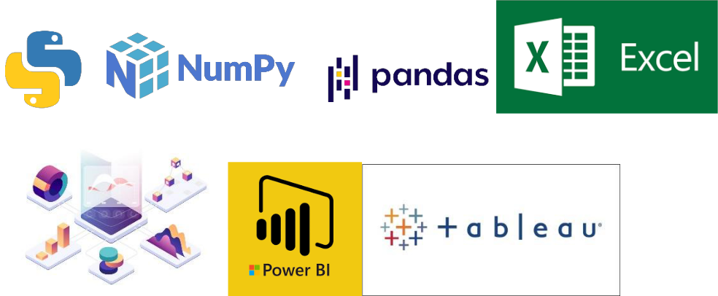



**3 Design Details**

**3.1 Functional Architecture**

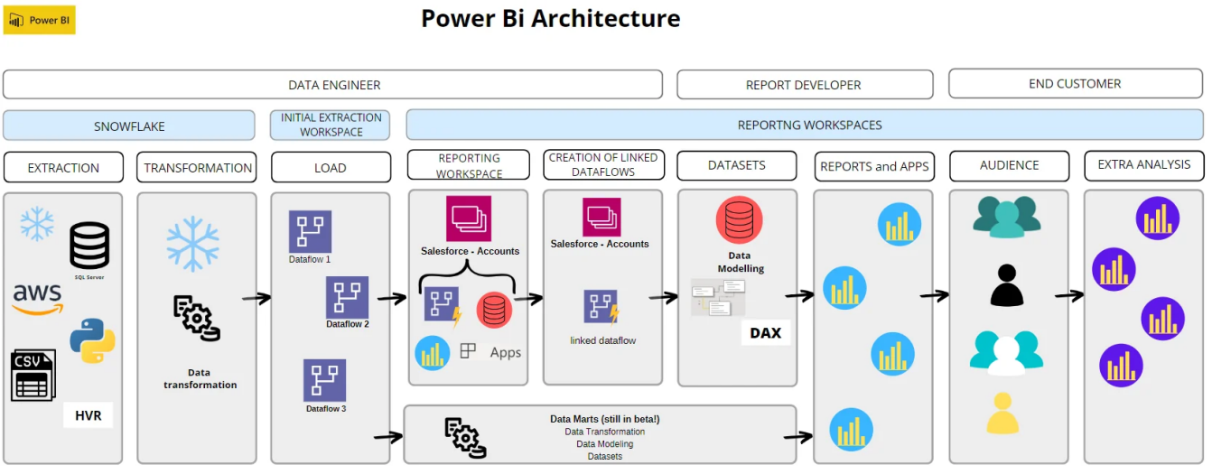

Figure 1: Functional Architecture of Business Intelligence

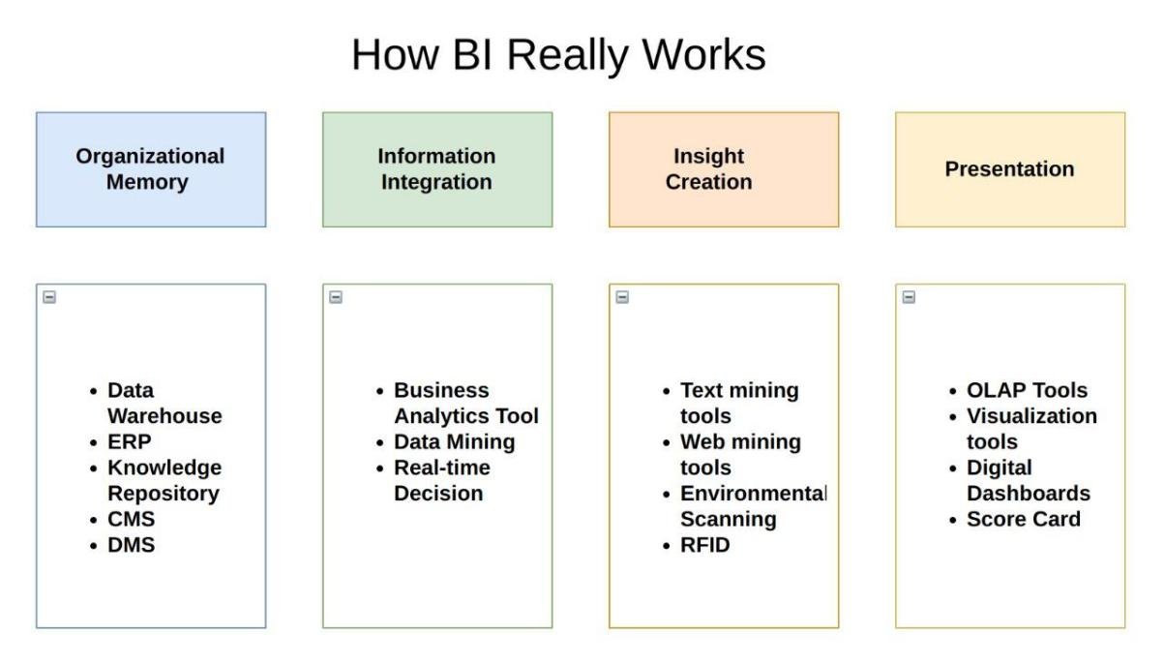

**3.2 Optimization**

For my data analysis project on entertainers, I organized the data into three main parts, capturing essential details such as each entertainer's name, birth year, death year, career-changing performance, and the year they first received a major award nomination. Additionally, I enhanced the dataset by manually adding information about the number of awards each entertainer has won. This includes the total number of nominations and specific counts for prestigious awards like Oscars, Emmys, and Grammys, sourced from IMDb's official website.

Since this project has no need for optimization, I focused on making the data meaningful and visually appealing. To achieve this, I applied filters to highlight only the top ten entertainers in various categories. This approach ensures that the most significant data points are easily accessible and understandable.

By showcasing the top ten entertainers with the most Oscars, the top ten with the most Emmys, and the top ten with the most Grammys, the analysis emphasizes the most notable achievements. This selective presentation makes the data more engaging for the audience and provides a clear, impactful view of the most distinguished entertainers in each category.

**4 KPIs**

Dashboards will be implemented to display and indicate certain KPIs and relevant indicators for the disease.



As and when, the system starts to capture the historical/periodic data for a user, the dashboards will be included to display charts over time with progress on various indicators or factors

**4.1 KPIs (Key Performance Indicators)**

Key indicators displaying a summary of the Entertainer’s Data with different metrics

1. Total number of movies acted by the Entertainer
2. Total Nominees
3. Total Awards
4. Most Oscars
5. Most Emmies
6. Most Grammies
7. Other Awards
8. Total Number of Males and Females
9. Best Performer based on Entertainer’s Rating

**5 Deployment**

When it comes to analyzing and visualizing data for improved comprehension, many companies and organizations turn to advanced business intelligence technologies, with Power BI emerging as a standout solution. With its array of services, Power BI offers robust tools for data analysis and visualization.

Specifically, Power BI Desktop is renowned for its accessibility and affordability—it's free for anyone to utilize. By harnessing Power BI Desktop, users can craft engaging visuals and dashboards that are seamlessly integrated with Power BI's cloud service. This facilitates easy sharing and collaboration, as users can distribute shareable links to grant access to specific reports or analyses.

[AUTHOR NAME]